"Experience the Magic of Kerala”
(5N/6D)

Discover the breathtaking beauty of Kerala, fondly known as "God's Own Country," on this unforgettable 6 Days / 5 Nights holiday. Explore the mist-covered tea plantations of Munnar, renowned for its scenic landscapes, the wildlife-rich forests of Thekkady and refreshing climate. Cruise through the tranquil backwaters of Alleppey aboard a traditional houseboat, surrounded by lush coconut groves and charming villages.

Experience the rich heritage and colonial charm of Kochi, home to iconic landmarks and vibrant local culture. This itinerary offers the perfect blend of nature, relaxation, and cultural exploration, making it an ideal getaway for families, couples, and nature enthusiasts seeking a memorable South Indian holiday.

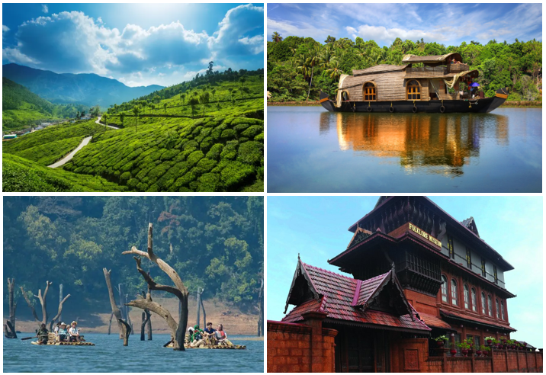

We wish you a happy, safe and unforgettable journey with us
Detailed Itinerary

Day 01: Arrive Kochi – Transfer to Munna (126 Km | 4 Hrs approx.)

Upon arrival at Cochin International Airport or Ernakulam Railway Station, meet our representative and drive to the picturesque hill station of Munnar. En route, enjoy the scenic beauty of lush green tea plantations, cascading waterfalls, and spice gardens. You may stop at Cheeyappara and Valara Waterfalls (seasonal) for photographs. Upon arrival, check in to the hotel and spend the rest of the evening at leisure. Overnight stay in Munnar.

Day 02: Munnar Sightseeing

After breakfast, enjoy a full-day sightseeing tour of Munnar, one of Kerala's most popular hill stations. Visit attractions such as Eravikulam National Park (subject to availability), Tea Museum, Mattupetty Dam, Echo Point, Kundala Lake, and Photo Point. Surrounded by misty hills and sprawling tea estates, Munnar offers breathtaking views and a refreshing escape into nature. Return to the hotel for an overnight stay in Munnar.

Day 03: Munnar to Thekkady (91 Km/3 Hrs approx.)
After breakfast, check out from the hotel and drive to Thekkady, a paradise for wildlife and spice lovers. On arrival, check in to the hotel and spend the day exploring the region's natural beauty. Visit a spice plantation or enjoy an optional boat cruise on Periyar Lake to spot elephants, deer, and other wildlife in Periyar Wildlife Sanctuary (at an additional cost). You may also enjoy activities like an elephant ride or a Kathakali and Kalaripayattu cultural show. Overnight stay in Thekkady.
Day 04: Thekkady – Alleppey (139 Km | 4 Hrs approx.)
After breakfast, check out and proceed to Alleppey, popularly known as the "Venice of the East." Upon arrival, check in to a traditional houseboat or hotel (as per your package). Cruise through the tranquil backwaters, passing lush paddy fields, coconut groves, and charming villages while witnessing the unique lifestyle of the local people. Relish authentic Kerala cuisine as you unwind amidst the serene surroundings. Overnight stay in Alleppey.
Day 05: Alleppey – Kochi (53 Km | 1.5 Hrs approx.)
After breakfast, check out from the houseboat and drive back to Kochi. Explore the city's famous attractions including Fort Kochi, the iconic Chinese Fishing Nets, St. Francis Church, Santa Cruz Basilica, Mattancherry Palace (Dutch Palace), and the historic Jew Town. Spend the evening shopping for spices, handicrafts, and souvenirs before checking in to your hotel. Overnight stay in Kochi.
Day 06: Kochi Depart
After breakfast, check out of the hotel and transfer to Cochin International Airport for your onward journey. Depart with wonderful memories of Kerala's misty hills, rich wildlife, tranquil backwaters, and vibrant cultural heritage. We wish you a safe journey and look forward to welcoming you again for another memorable holiday.

Tour ends with unforgettable memories

Destination/Nights | 3* Hotel Name
Munnar /02N
Thekkady /01N
Alleppey /01N | Houseboat
Kochi /01N
HOTELS DETAILS:

Package Cost:

3★ Hotels: Rs. per person (Based on 6 guests – Double Sharing Basis)

Inclusion: -
- Breakfast Included.
- 0 DBL Room on sharing based.
- 04 Nights in Accommodation in hotel.
- 01 Night in Super Deluxe Houseboat in Alleppey.
- Assistance on Arrival.
- All Transfers and S.S tours by AC [Pick Up Kochi – Drop at Kochi]
Exclusions: -
- 5% GST.
- Flight Tickets are not included.
- Guide.
- Extra meal not included or as per the inclusions given above.
- Vehicle not at disposal.
- No extra pickup or drop included for lunch/sightseeing unless otherwise mentioned in the itinerary.

